# Purpose

* Quickly create sim files for Synchro.
* Ensure consistent header/footer naming for other Python Script (ReportToTable_ZonedReports.py)

# Requirements

1. A text file named “**Report Headers.txt**” is required. This file is manually made. Each row is information for each sim file. Example of the text file is below

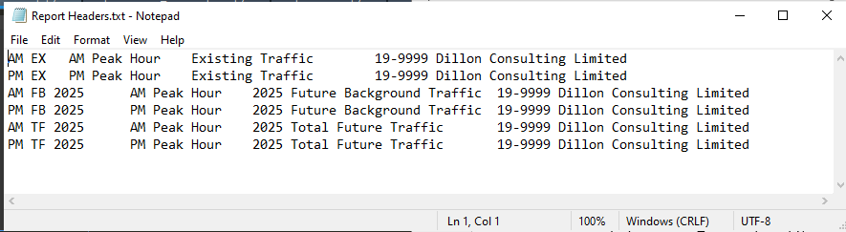

This text file is delimited by tabs.

**Contents of Report Headers.txt**

Column 1 is the name of the sim file (This must match Synchro file names)

Column 2 is the peak hour name (goes to top right of Synchro report headers). Column 2 is also used in ReportToTable_ZonedReports.py

Column 3 is scenario name (goes to bottom right of Synchro report headers). Note: order of rows is important as it will dictate order of how results are presented (more information in READ ME - ResultsToTable_ZonedReports.docx)

This is a consequence of how ReportToTable_ZonedReports.py is written

Horizon year must come first if present in the scenario name. The suggested row order is: Exist (AM then PM), Future Background (AM then PM), Total Future (AM then PM)

Column 4 is project number (not used for Brent Hooton project, used for Tim Kooistra’s projects occasionally)

Column 5 is analyst’s name (not typically used, occasionally used for Tim K’s project)

NOTE: make sure “Headers1” “Headers3” “Headers4” and “Headers6” are empty in the sim file. This is because the python script writes Columns 2,3,4,5 after the = sign.

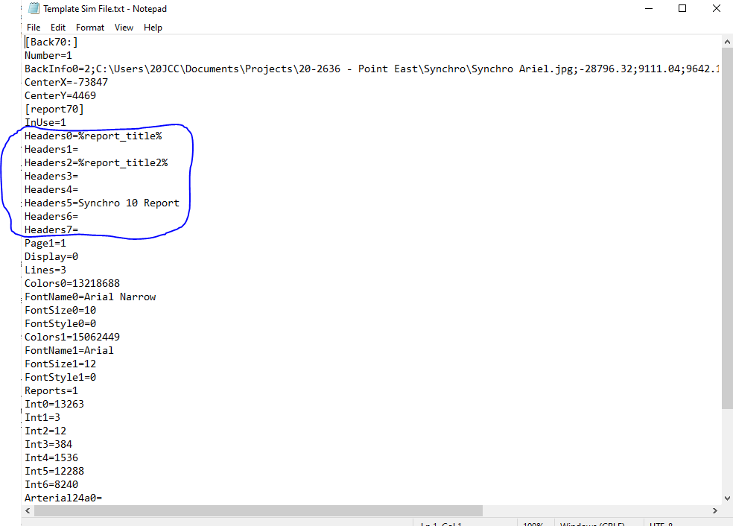

1. A text file named “**Template Sim File.txt**” is required. This file is manually made with Synchro.
   1. Once the Synchro file is read, create a dummy PDF operation report. Doing this will create a sim file with the desired format. Open the sim file with a text reader (Notepad or Notepad++), copy the content and paste into Template Sim File.txt.

# How it works (Overview)

* Script takes Report Headers.txt and Template Sim File.txt and creates sim files for Synchro files.
* When you run the code, it will ask you for the directory where Report Headers.txt and Template Sim File.txt are located.

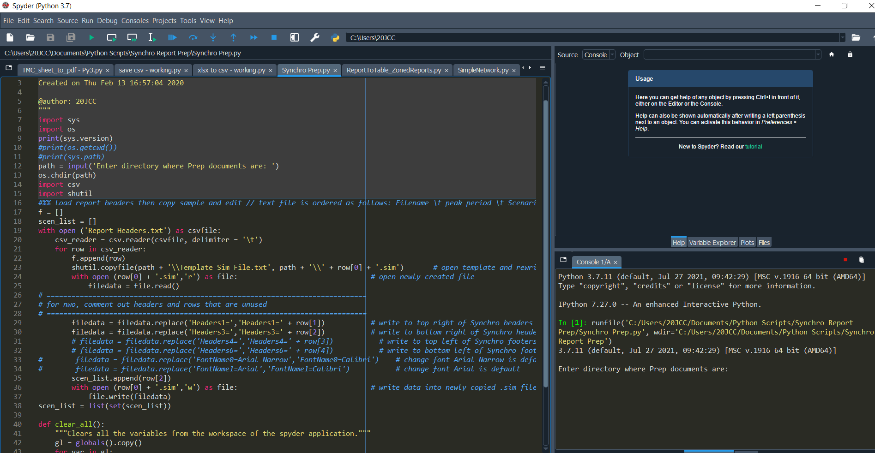

Input the full window explorer directory for the script and press ‘enter’ to continue. E.g.

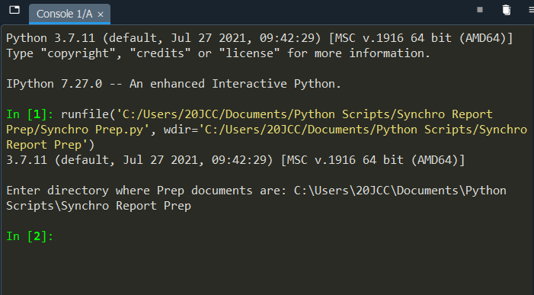

# Outputs

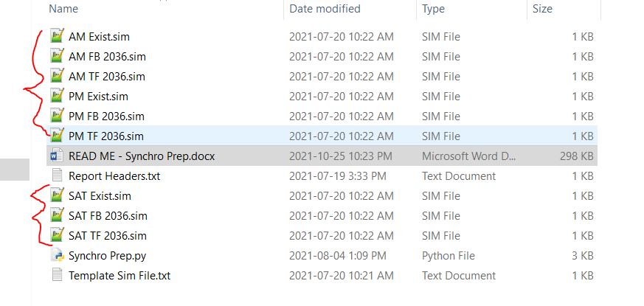

If done correctly, your Synchro Headers will be as such:

